**Task 2**

**Load Testing:**

**Test Case:**

Simulate Concurrent Users Accessing the GET /users Endpoint: (Public endpoint)

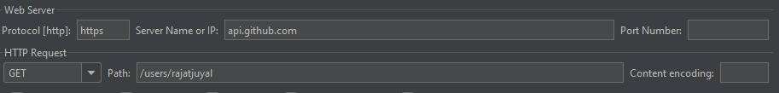

* Set up a load testing script with JMeter.
* Define the number of concurrent users and spawn rate.
  + **Concurrent users – 1000 and spawn rate is 5 arrivals /seconds**
* Test for a specific time period or a number of requests
  + **10 seconds**
* Measure response times, error rates, and system behavior under load.
  + 